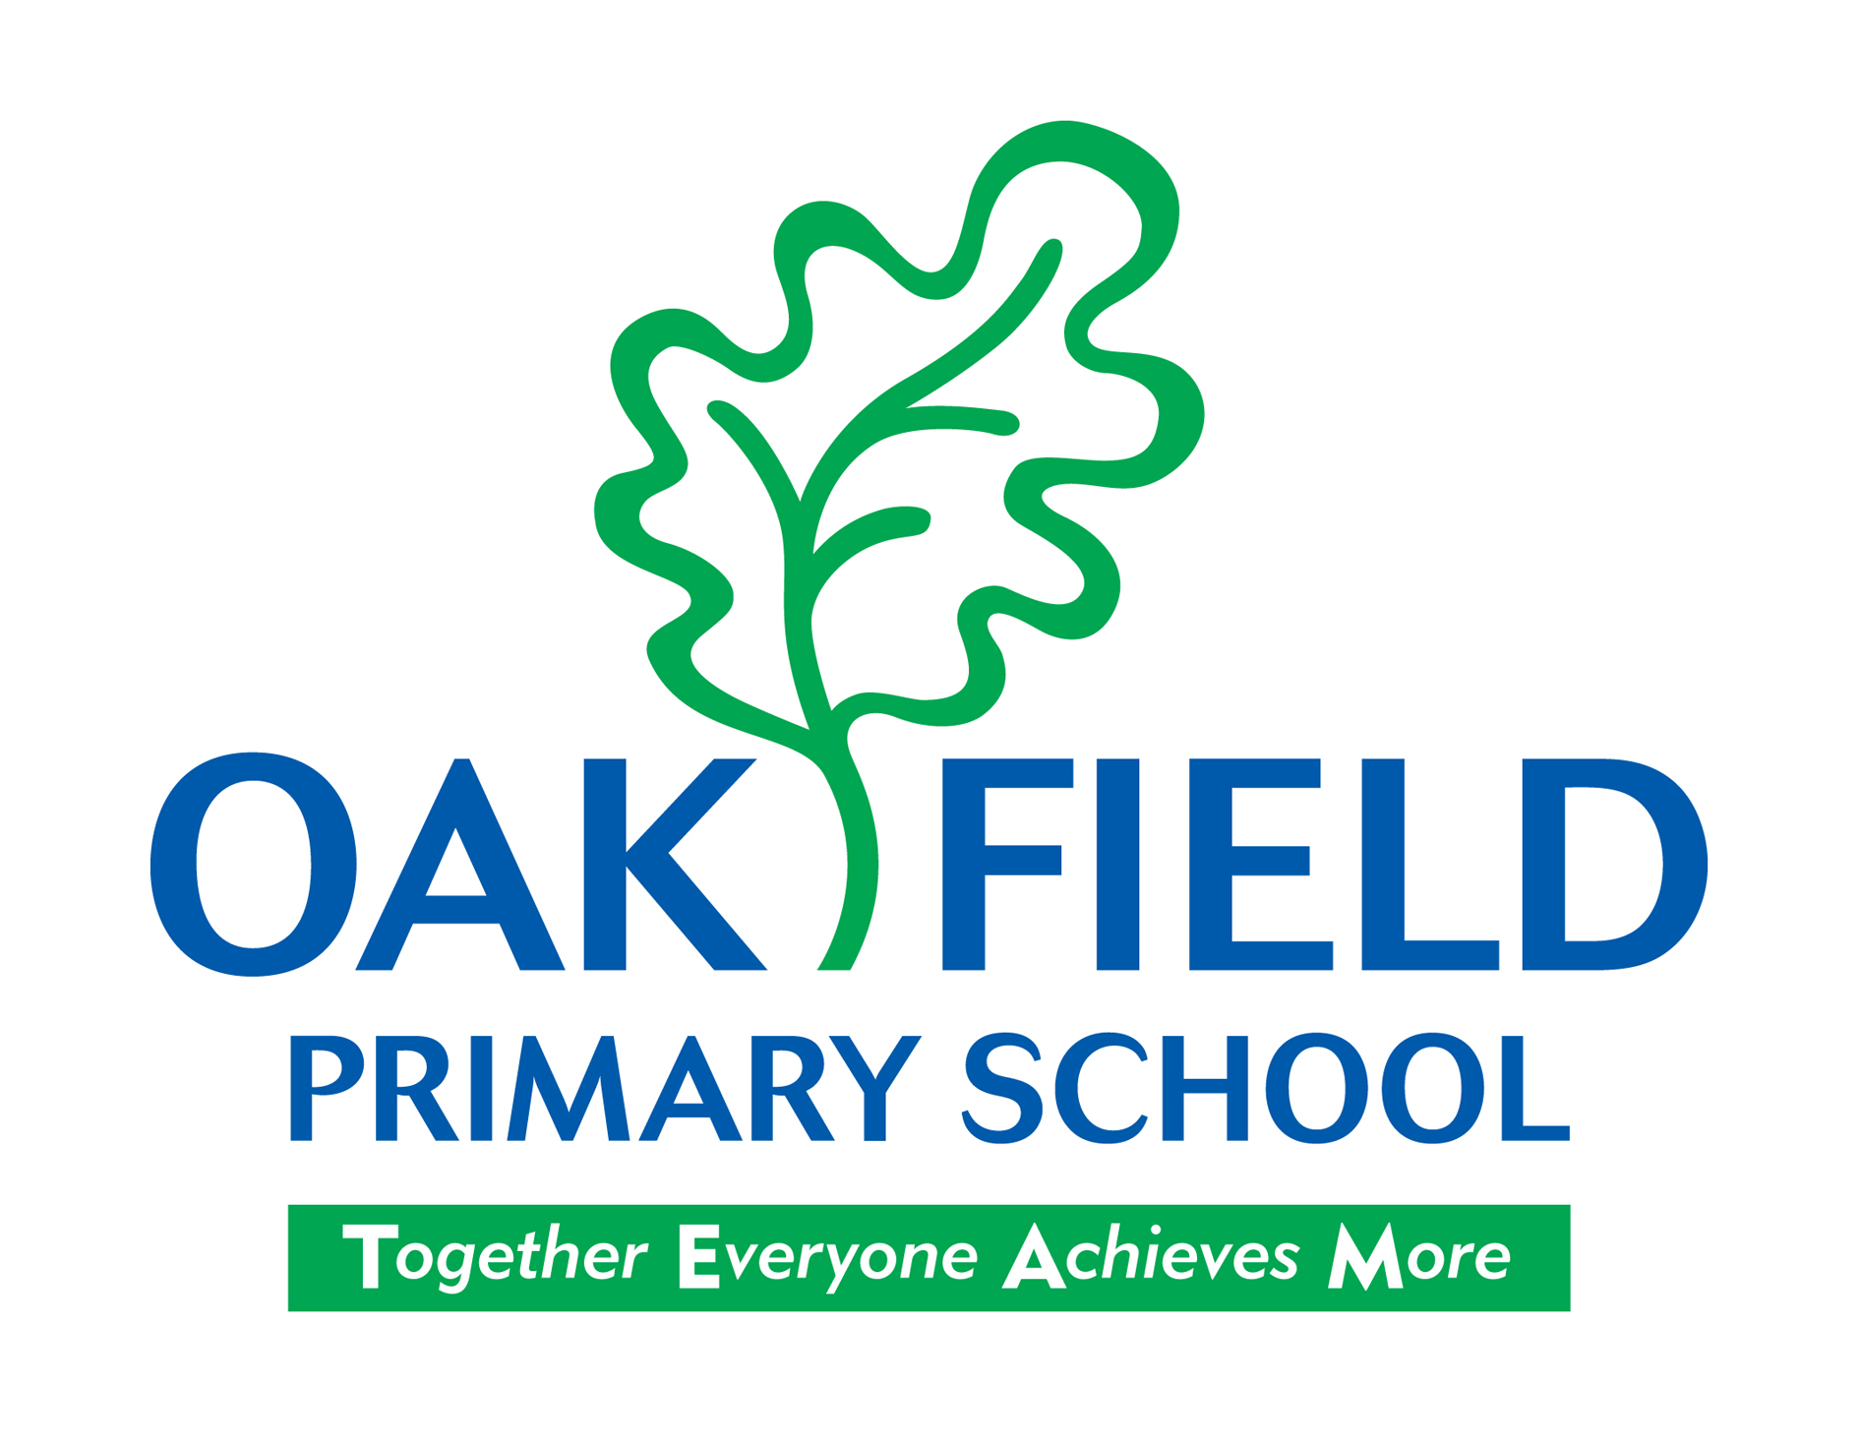

PDG Evaluation
September 2018

Context
The school is located in an area of high deprivation. Currently 64% of pupils are eFSM. The school has calculated that 82% of pupils have been eFSM at some point during their time at the school. The school received £92,950 in PDG in 2017-2018 and £77,625 this year as well as £24,500 for Early Years.

PDG spend 2017-2018
- Full time Nurture provision
- Literacy and Numeracy interventions
- Enrichment activities
- Further development of restorative approaches across the school
- Improve attendance

